Maksat Nurtai CSSE-1605

So this time we worked on the Naive Bayes algorithm. Bayes Theorem finds the probability of an event occurring given the probability of another event that has already occurred. Bayes’ theorem is stated mathematically as the following equation:

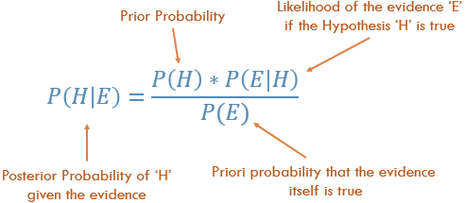

Basically, we are trying to find probability of event H, given the event E is true. Event E is also termed as evidence.

To work among the algorithms, we chose the GaussianNB. In Gaussian Naive Bayes, continuous values associated with each feature are assumed to be distributed according to a Gaussian distribution. A Gaussian distribution is also called Normal distribution. When plotted, it gives a bell shaped curve which is symmetric about the mean of the feature values as shown below:

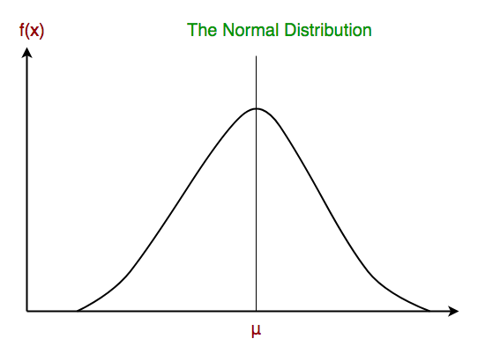

At the end, I compared all the algorithms that we studied. And here are their results: (dataset: Social_Network)

